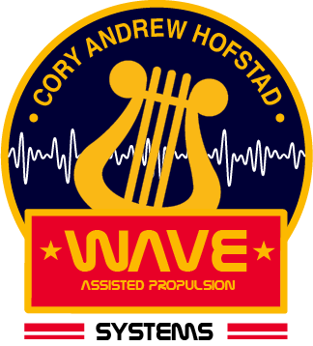

**Wave Assisted Propulsion Systems**

*Sound waves that create rotational patterns in an ion cloud for the purpose of accelerated ejection by coulomb’s force following the right-hand rule.*

**Independent Study | North Seattle College**

Cory Andrew Hofstad

1. **Introduction page 2**
2. **Research Question page 3**
3. **Methods page 4**
4. **Timeline page 6**
5. **Results page 7**
6. **Conclusion page 10**
7. **Data Repository page 11**
8. **Introduction**

The wave assisted propulsion system project develops and studies novel electronic propulsion methods which use acoustic catalysts. The project was started within North Seattle College’s Undergraduate Research 294 Program in Fall of 2017, by aerospace engineering student Cory Andrew Hofstad. Plasma Vortex Theory was developed during a night spent watching back to back NASA aerospace videos on YouTube looking for a project idea for UGR 294. From the observation of rotational formations created in Lycopodium in the video documentary “Cymatic Soundscapes” by Hans Jenny, a theory was derived by Combining Newtons’ first law of motion with Lorentz force law and Coulomb’s force law. The theory stated that “*Through Lorentz force and the right-hand rule, an electroacoustic method could be used to increase an ionized particle’s velocity parallel to an electromagnetic field.”* and that “*A rotating ion cloud will have a higher final velocity then an ion cloud at rest when electromagnetic fields of equal force are applied.*”

Electric propulsion systems depend on a hybrid combination of electrical energy and chemical fuel to create thrust. These systems are relied on by space flight missions for their ability to extend the life of a finite chemical fuel supply. During prolonged orbits and extended travel timelines, EP drives and thrusters are able to increase distances which an applied space craft is able to travel. Future spaceflight missions need increasingly efficient propulsion systems for long term orbital missions and interplanetary or interstellar transit missions. In electric propulsion applications, thruster performance is generally measured in terms of the efficiency at which chemical fuel is spent to achieve a measured thrust force. Published methods for increasing thruster performance include manipulation of cathode shape (2), wall materials (3), anode geometry (4), channel length (5), magnetic field strength (6) and column configuration (7).

Electroacoustic propulsion is a method of accelerating a chemical propellant using waves of sound inside a thruster column or pre-exhaust chamber. This process of increasing kinetic energy is designed to operate as a catalyst for creating exhaust velocities in cooperation with traditional electric propulsion methods.

1. **Research Question**

This experiment questions whether positive changes in force can be created in common thruster configurations when the ions are accelerated in a right hand rotational path. Electronic propulsion systems in use and under development until 2018 have traditionally converted electricity into electrostatic, electromagnetic or thermal fields which are used to accelerate or expand a chemical fuel to create thrust.

[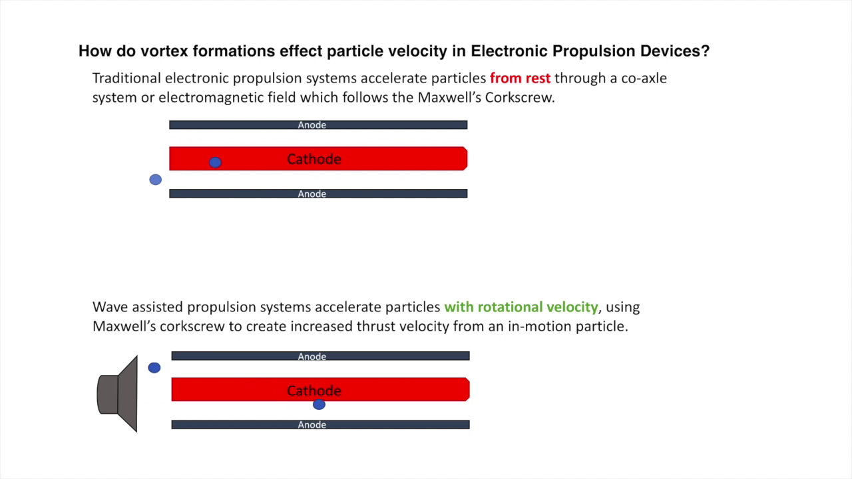](https://youtu.be/DBkf-nS7o5k?t=16m57s)

During Winter 2018, the initial Plasma Vortex Research proposal for workspace and project funding through the UGR program was denied due to lack of aerospace engineering enrollment in the program and available workspace or advising on campus. With a breakout idea in space flight technology but no approved workbench, the future of electroacoustic propulsion was in question. A new open source method was developed, a repository was started on Github, and work was discussed with students and faculty at nearby University of Washington, Seattle University, Shoreline, Edmonds, Seattle Central and South Seattle Colleges.

Tracy Furatunami of the Engineering department at North Seattle College introduced the Cory Hofstad to the rocket club and explained how it was a privately funded program which has success in aerospace engineering projects. The initial proposal was published as an open source application of aerospace engineering principals after positive review was received from peers within the local collegiate system. The undergraduate research program was then used to develop theoretical applications and design an academic experiment which could be done within a privately funded budget.

1. **Methods**

This experiment is designed to study the effects of audio spectrum frequencies on a simple electronic propulsion system from which data is attained. A modular electroacoustic propulsion system is being developed to record and observe the effects of sound waves on gaseous propellants inside common thruster configurations. The project is in startup phase and is currently working on plans to create light thrust from oxygen ions within the thruster housing as a method of supplementing available test mediums, which in early proposals were a concern of campus safety officers.

A 9” dual coil wave driver is mounted at one end of the column and used to create acoustic resonance of varying frequencies. Frequencies are generated by software application on a MacBook Pro, audio signal from the application is sent from the computer system to an audio amplifier which is powered by a Corsair 750-Watt power supply which has been modified for this experiment.

During the initial brainstorming stages, emphasis on designing a modular research environment in which a multitude of experiments could be carried out using various instruments and attachments. The current arrangement of a single foot of acrylic as a base to the wave driver serves as an area to attach secondary lengths of acrylic, polymer, metal or cardboard module prototypes. This space is suitable for co-axle configurations, magnetic gratings, cathode /anode arrangements, measuring devices and recording equipment

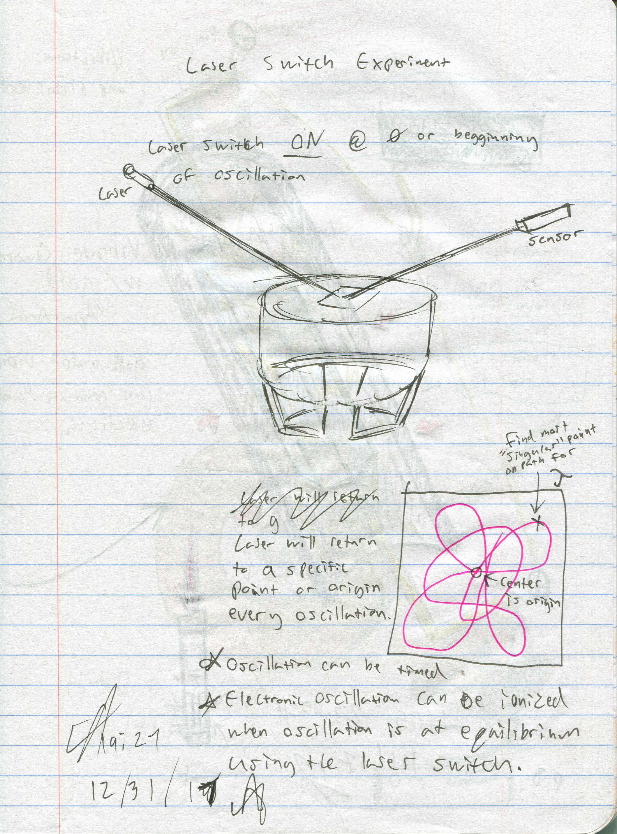 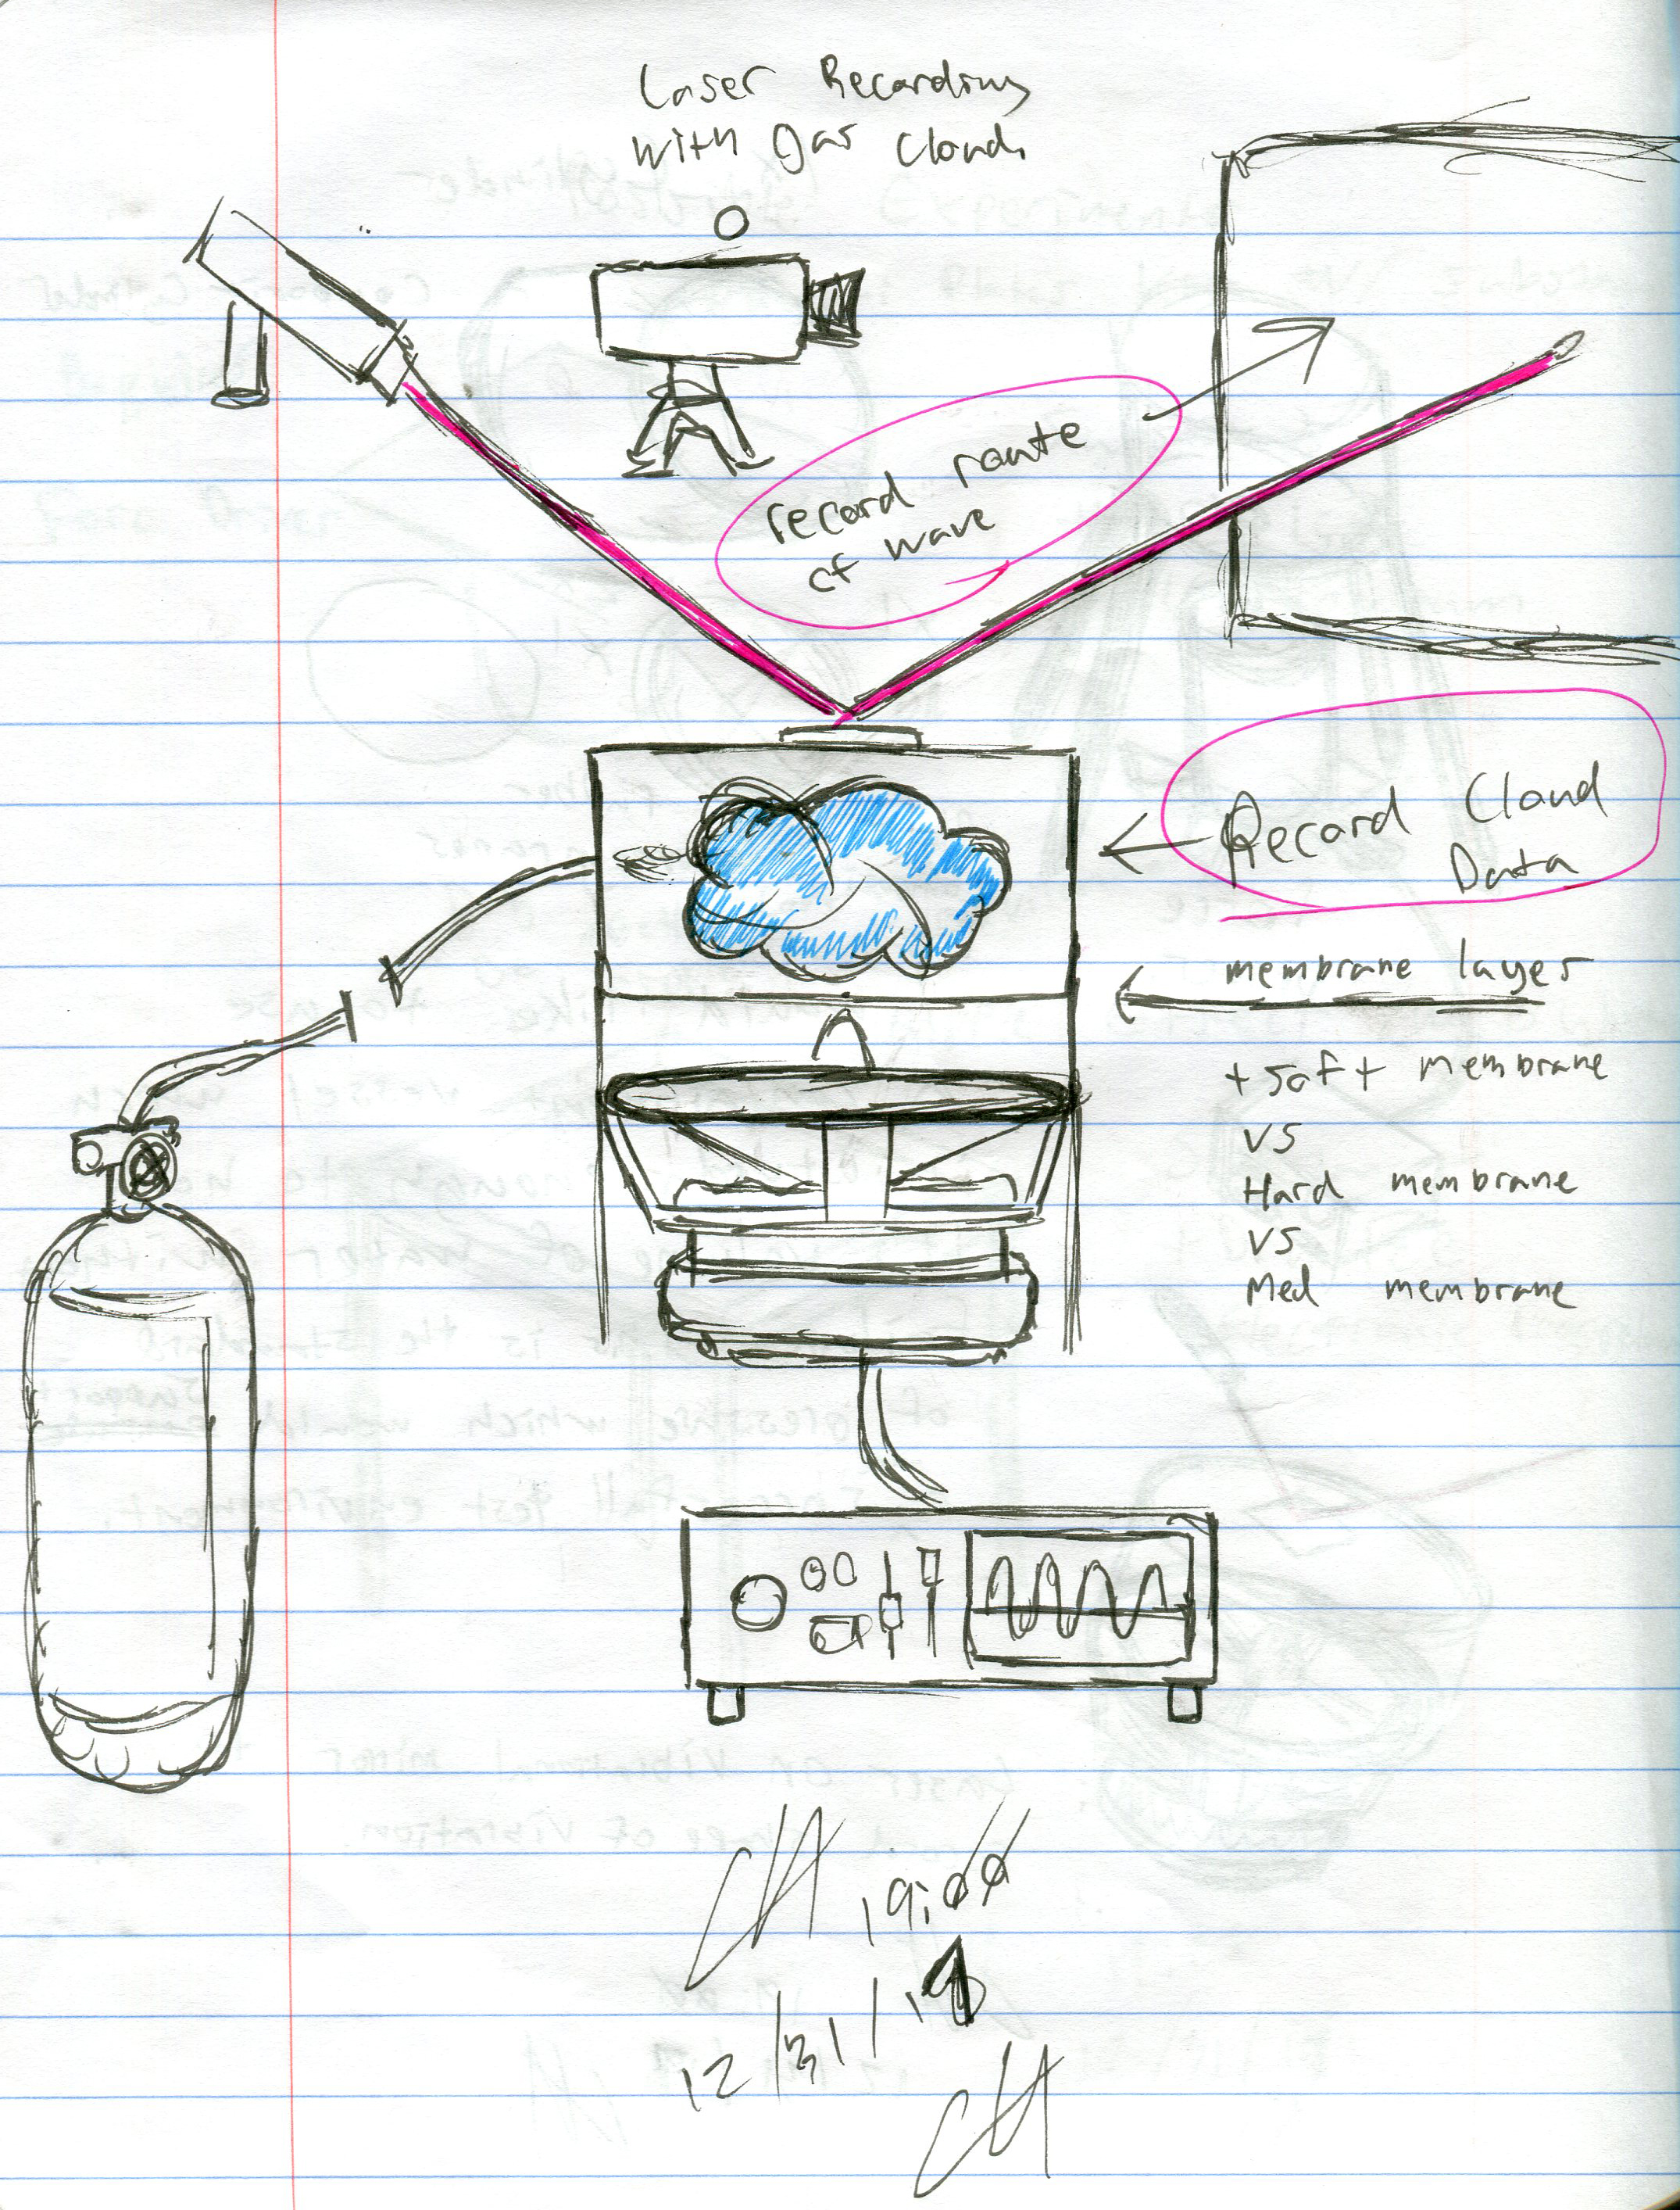 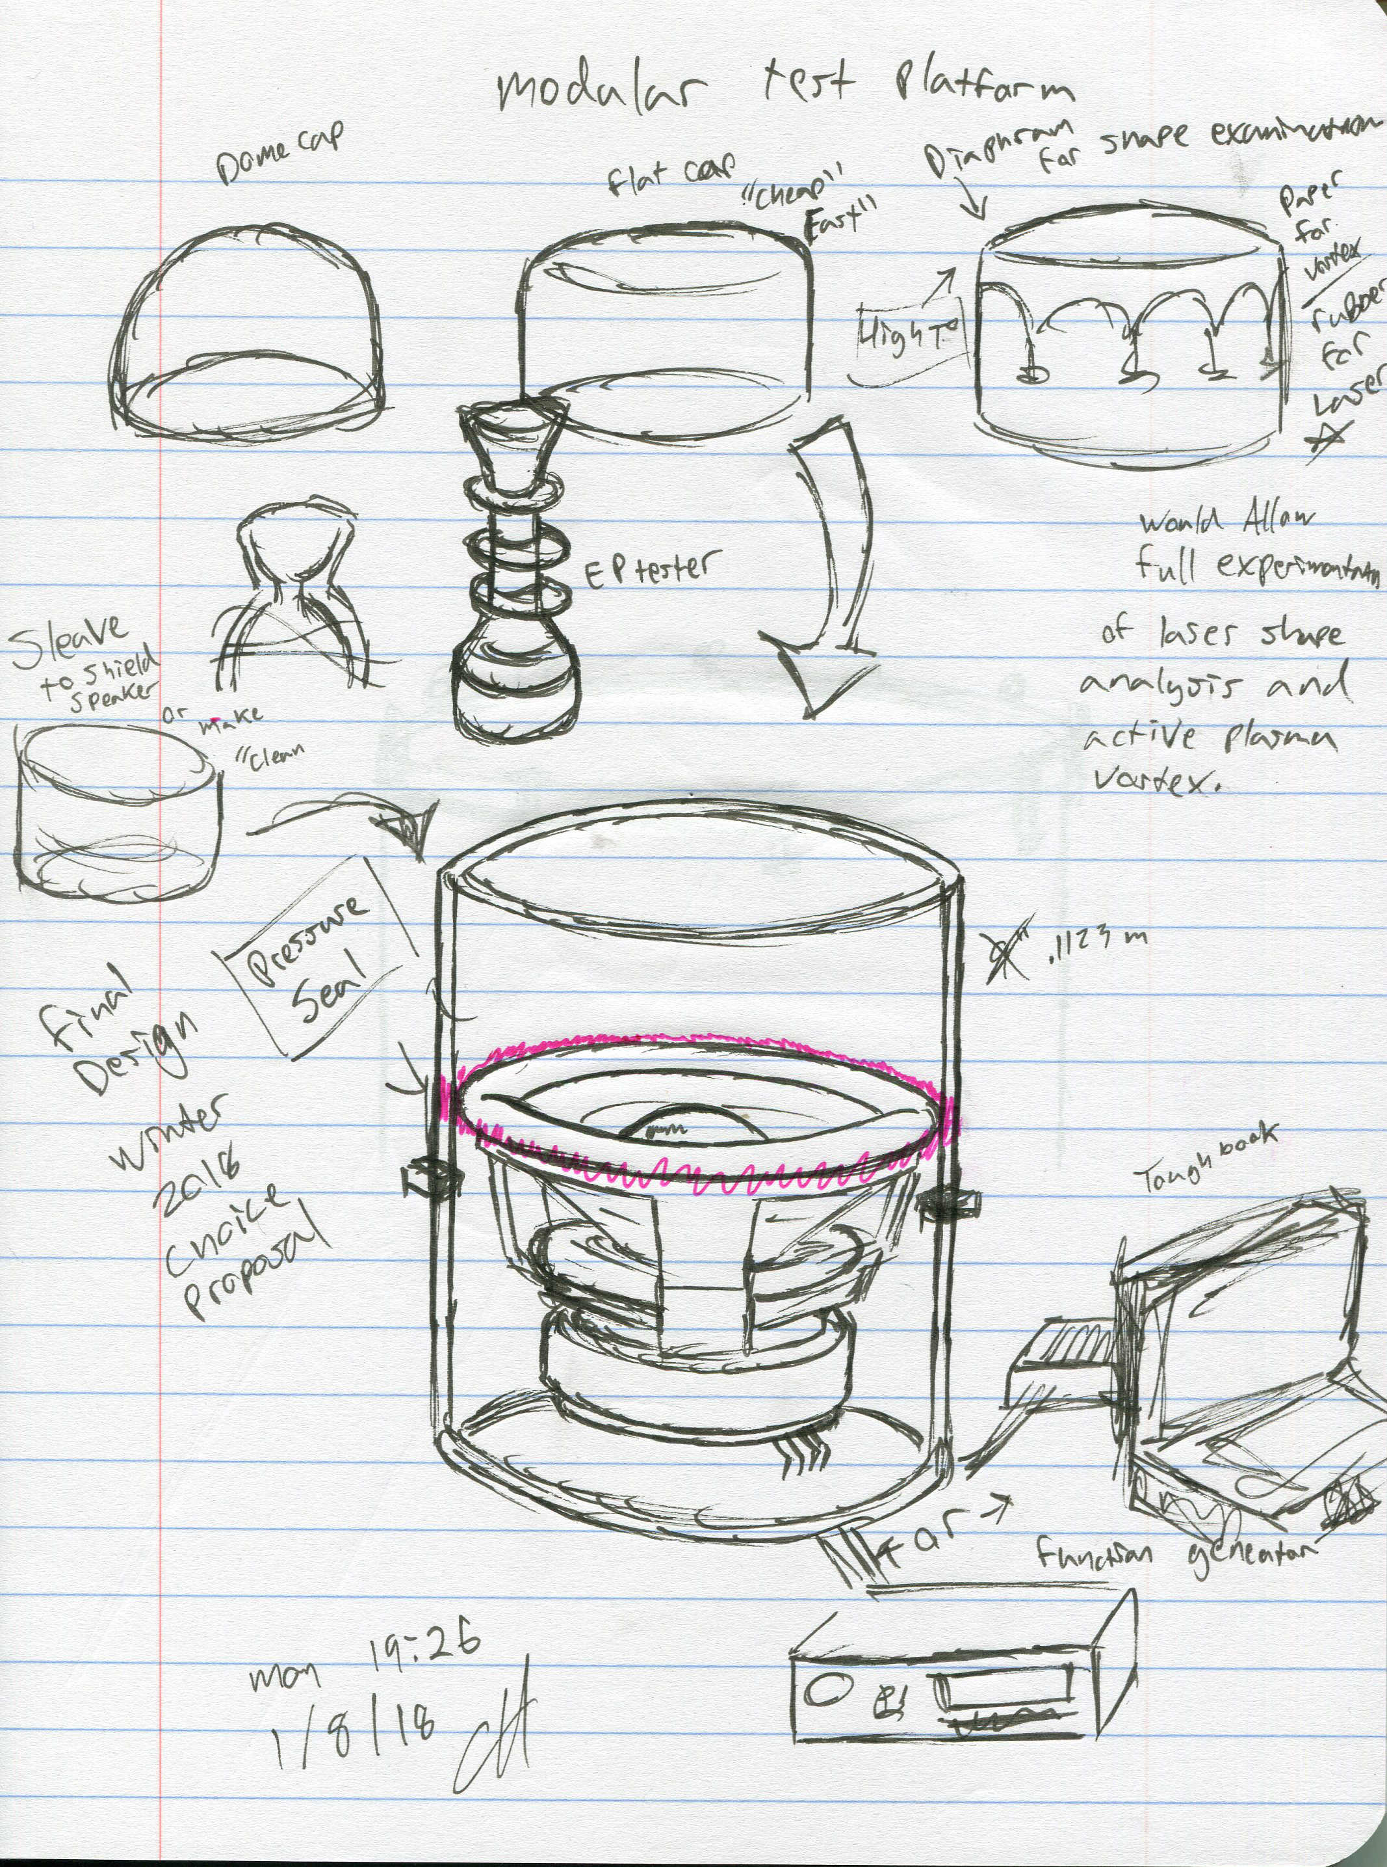

**Resonance and Observation**

Lycopodium is used as a visual tool during acoustic calibration, which allows researchers to observe geometric patterns in frequencies produced during the experiment. The mounting section of the experimental column is an extruded acrylic tube with an outer diameter of 9.5” and inner diameter of 9”. For oscillation of Lycopodium, a 7’ cardboard form tube with similar diameter is attached to create a resonance column for research using acoustical resonance.

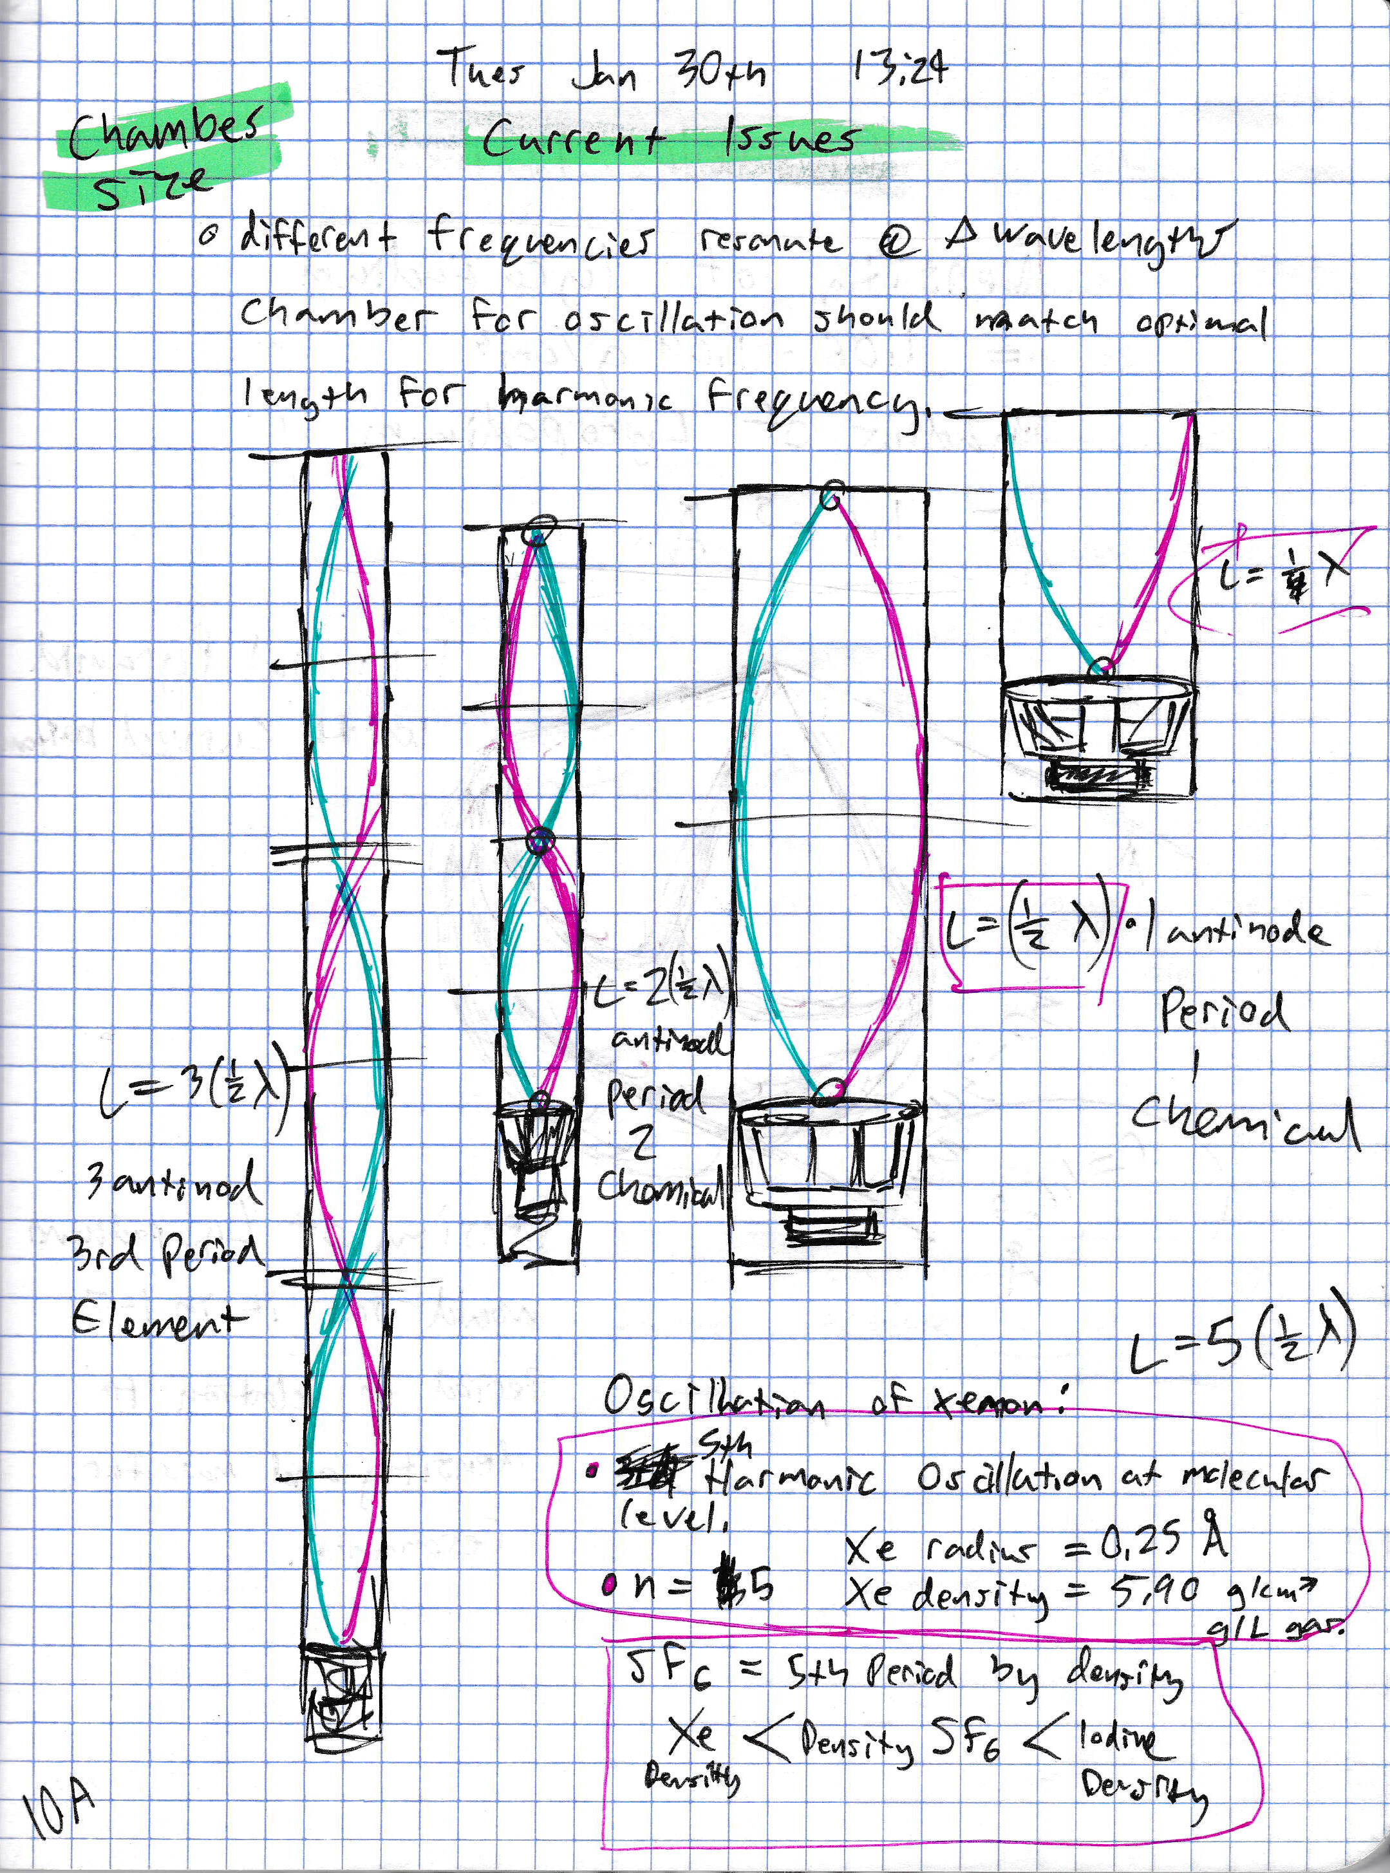

Using the physics equation for a standing wave in open and closed end containers, resonance lengths for varying frequencies will be used to observe and record rotational formations.

An adjustable stopper of lightweight affordable material will provide a means to vary the column length for a range of frequencies and accompanied wavelengths.

During this experiment, qualitative data for soundwave formations within a thruster column are recorded and observed. The main goal for early experiments is to develop a novel method that uses sound as a catalyst to accelerate ionic particles using electricity. Improving the efficiency at which vehicles expend chemical fuel during extended space flight missions. Data related to power consumption and electrical input will not be investigated at this time.

**Propulsion**

A method which is currently being developed as a propulsion strategy uses no chemical fuel and instead operates through the use of a cathode and anode arranged as to ionize oxygen and creating thrust from the surrounding atmosphere. This method involves creating a propulsion module for the research platform which consists of a positively charged coil near the bottom of the acrylic cylinder which would draw electrons from a negatively charged anode column. Electrons which are drawn from the anode to the cathode would knock of electrons from the oxygen molecules within our electroacoustic chamber creating positively charged ions.

The increasingly positive and negative fields created by the cathode and anode accelerate the oxygen ions using coulomb’s force and the dielectric effect to create thrust. A force baseline for this thruster configuration will be recorded. The embedded wave driver is then used to oscillate the ionized molecules within the thruster. Thrust data for the baseline force and data recorded during periods of harmonic oscillation of calibrated frequencies will be compared from multiple readings which represent efficiency of the experimental method.

1. **Timeline**

Plans for summer quarter involve continually adding to the electroacoustic research portfolio and seeking additional public funding for equipment and hardware. Increased thrust during periods of applied harmonic oscillation will be used as a proof of concept for acquiring funding for further electroacoustic propulsion prototyping which will involve engineering low weight, highly energy efficient embedded control systems, signal amplification, wave driver and housing components to determine realistic power draws and thrust to weight ratios which will be needed for realistic testing for applications in space.

**Immediate Goals:**

* Hard numbers are needed for frequency and amplitude combinations that create vortex patterns suitable for propulsion research. Certain ranges have been observed in this area but need to be investigated with columns of the proper wavelength to achieve harmonic resonance.
* A 2000-Watt power supply is needed to provide completely power the 1600-Watt amplifier and Dual Coil Wave Driver
* Funds must be raised for new materials, measurement instruments and recording devices.

1. **Results**

What has been accomplished during Spring Quarter of 2018 is that the groundwork for a modular electronic propulsion lab has been design and constructed with a budget of $500. The portions of the thruster which have are currently functioning are the main cabinet housing, wave driver, signal amplifier, signal power supply, computer based electroacoustic generator and a single foot of 9” diameter acrylic tube which serves as a joint section for attaching modules which can be developed using affordable materials.

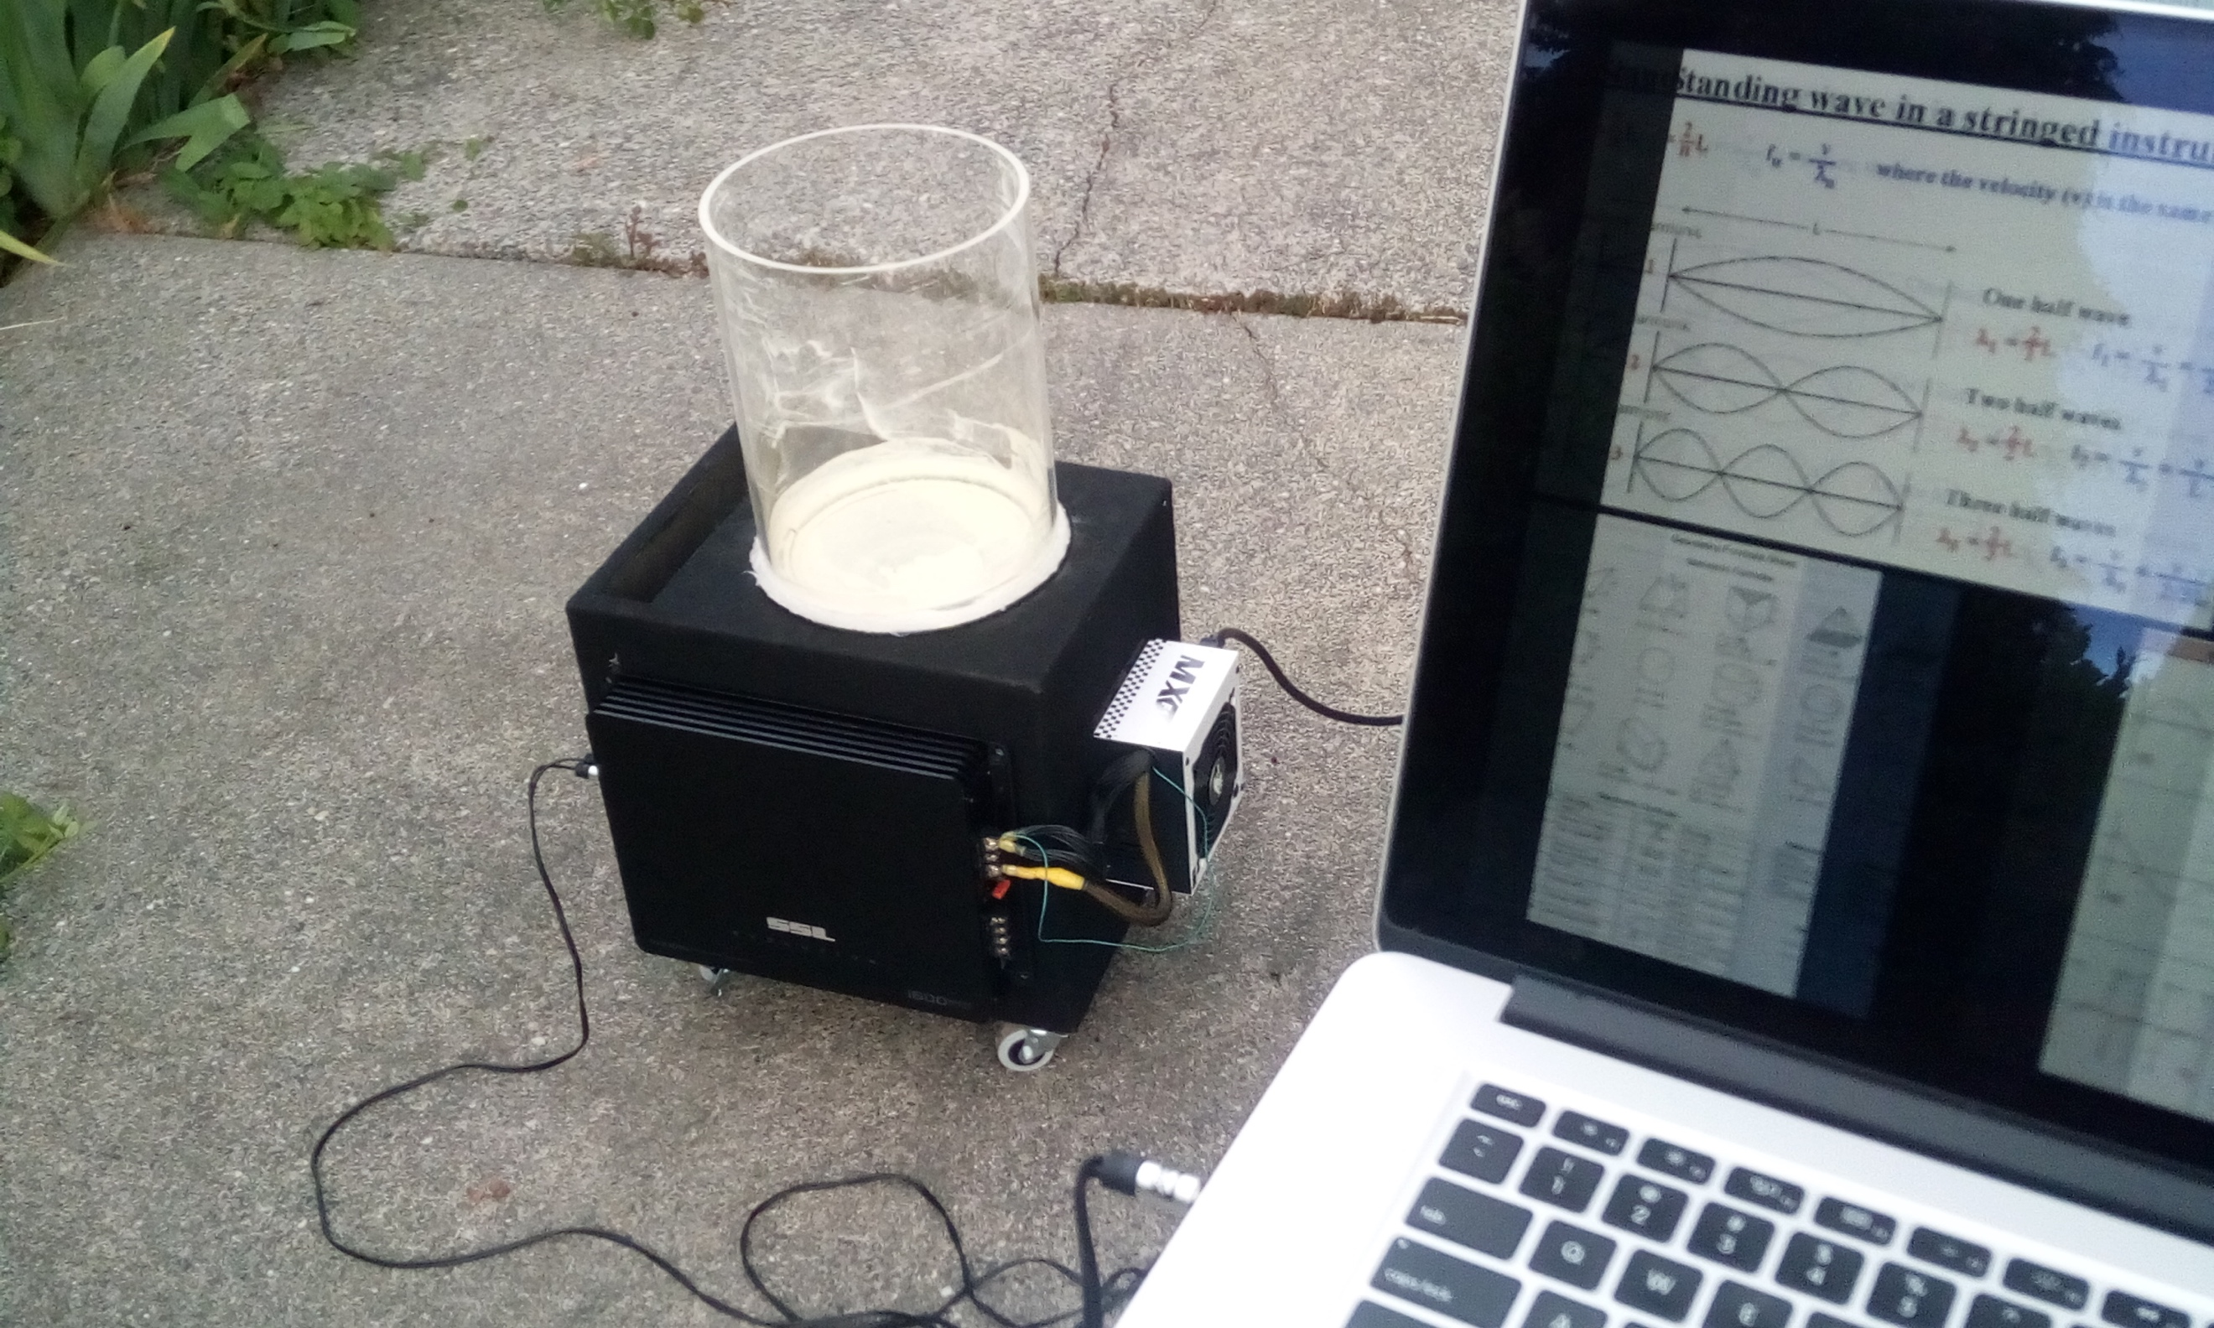

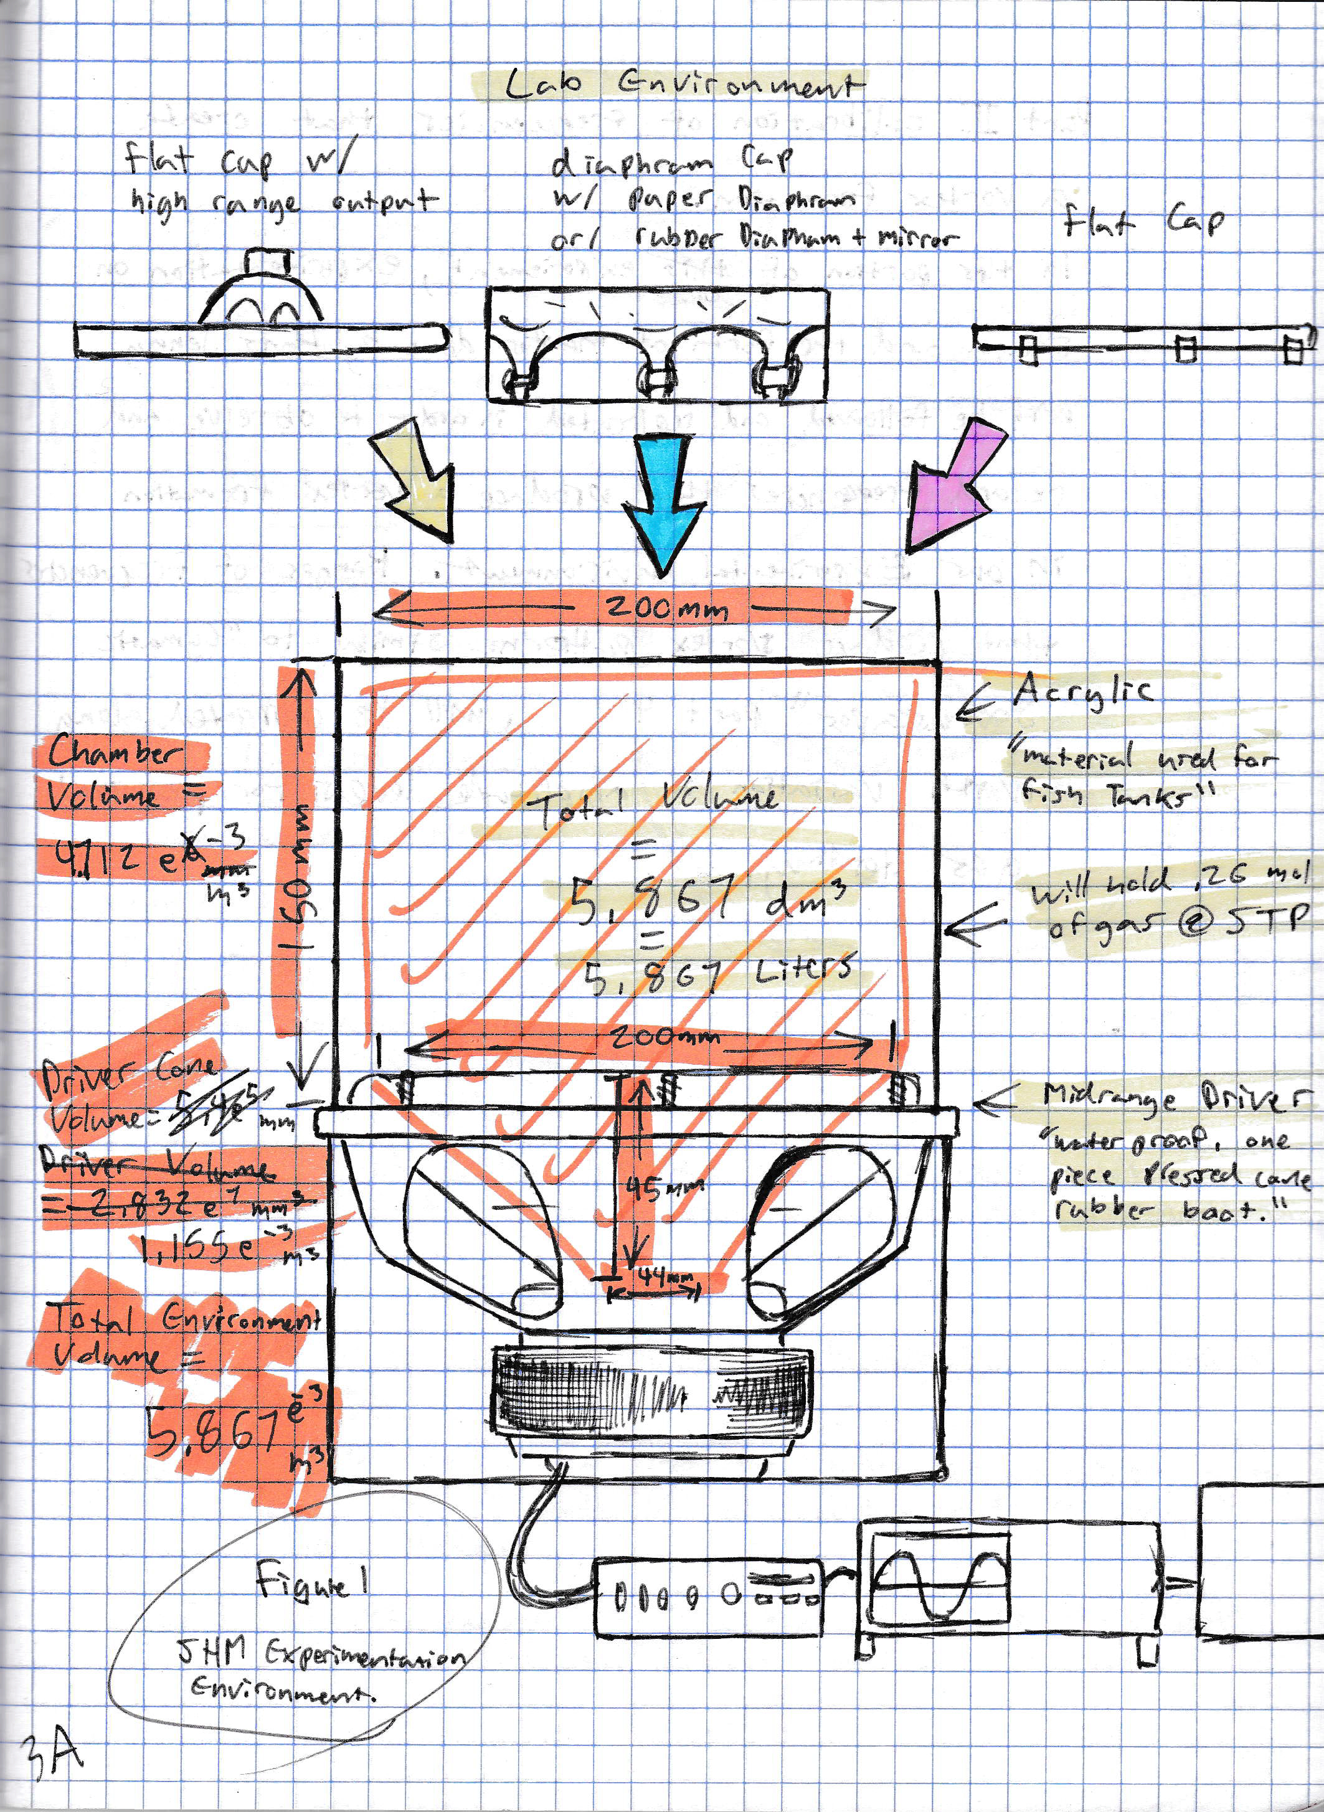 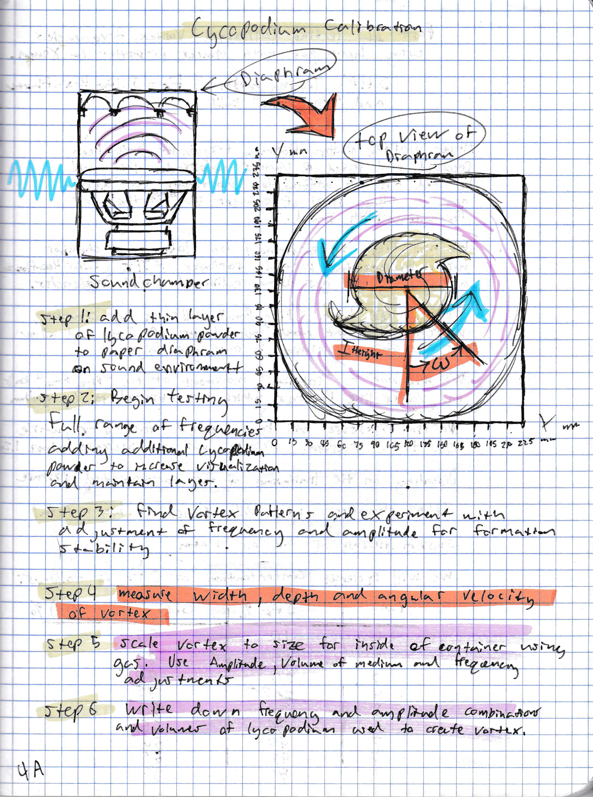 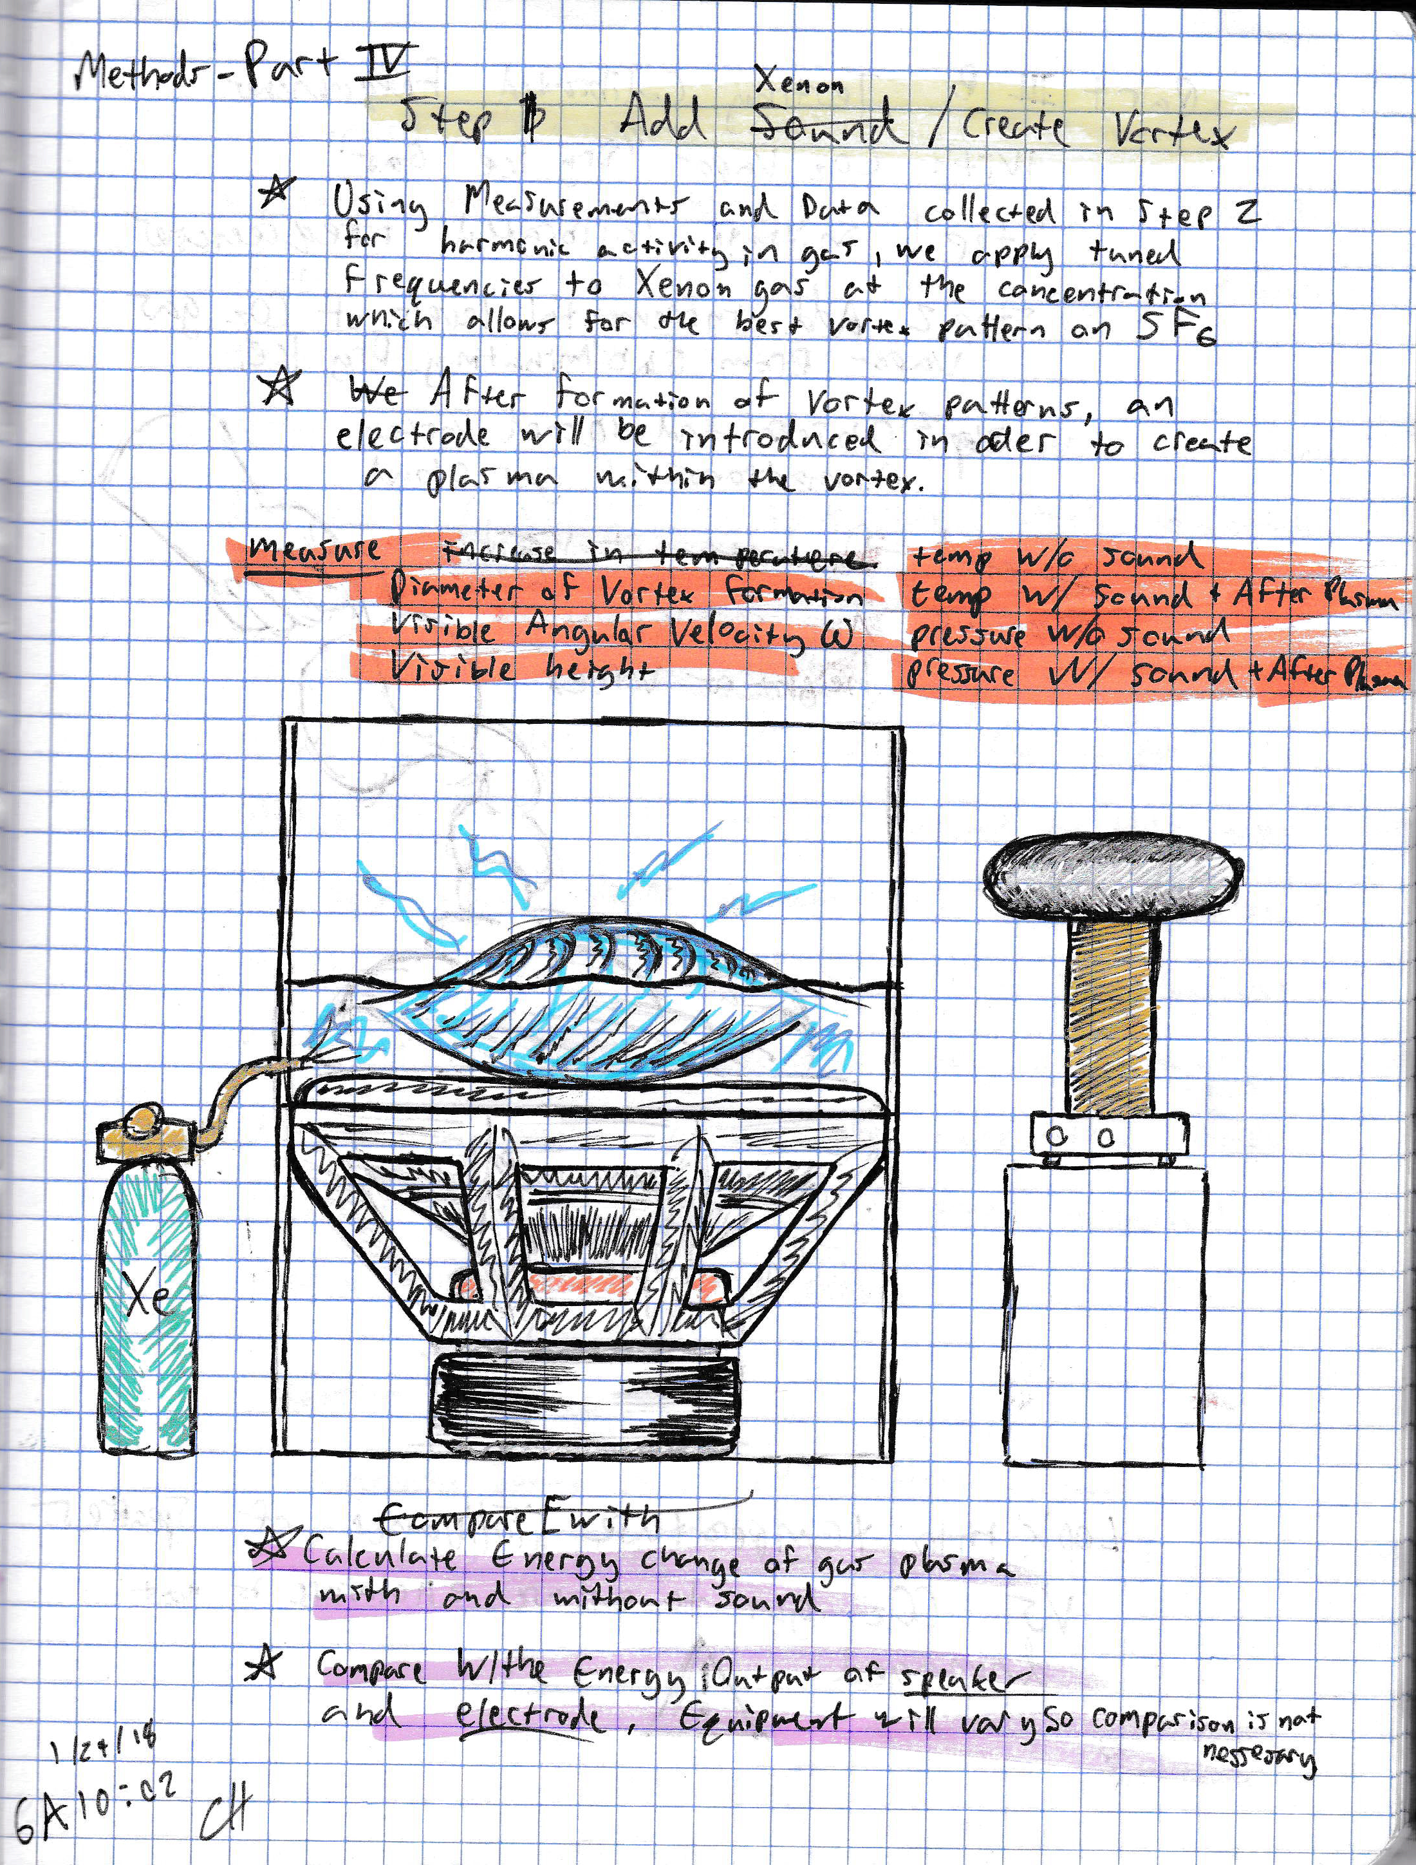

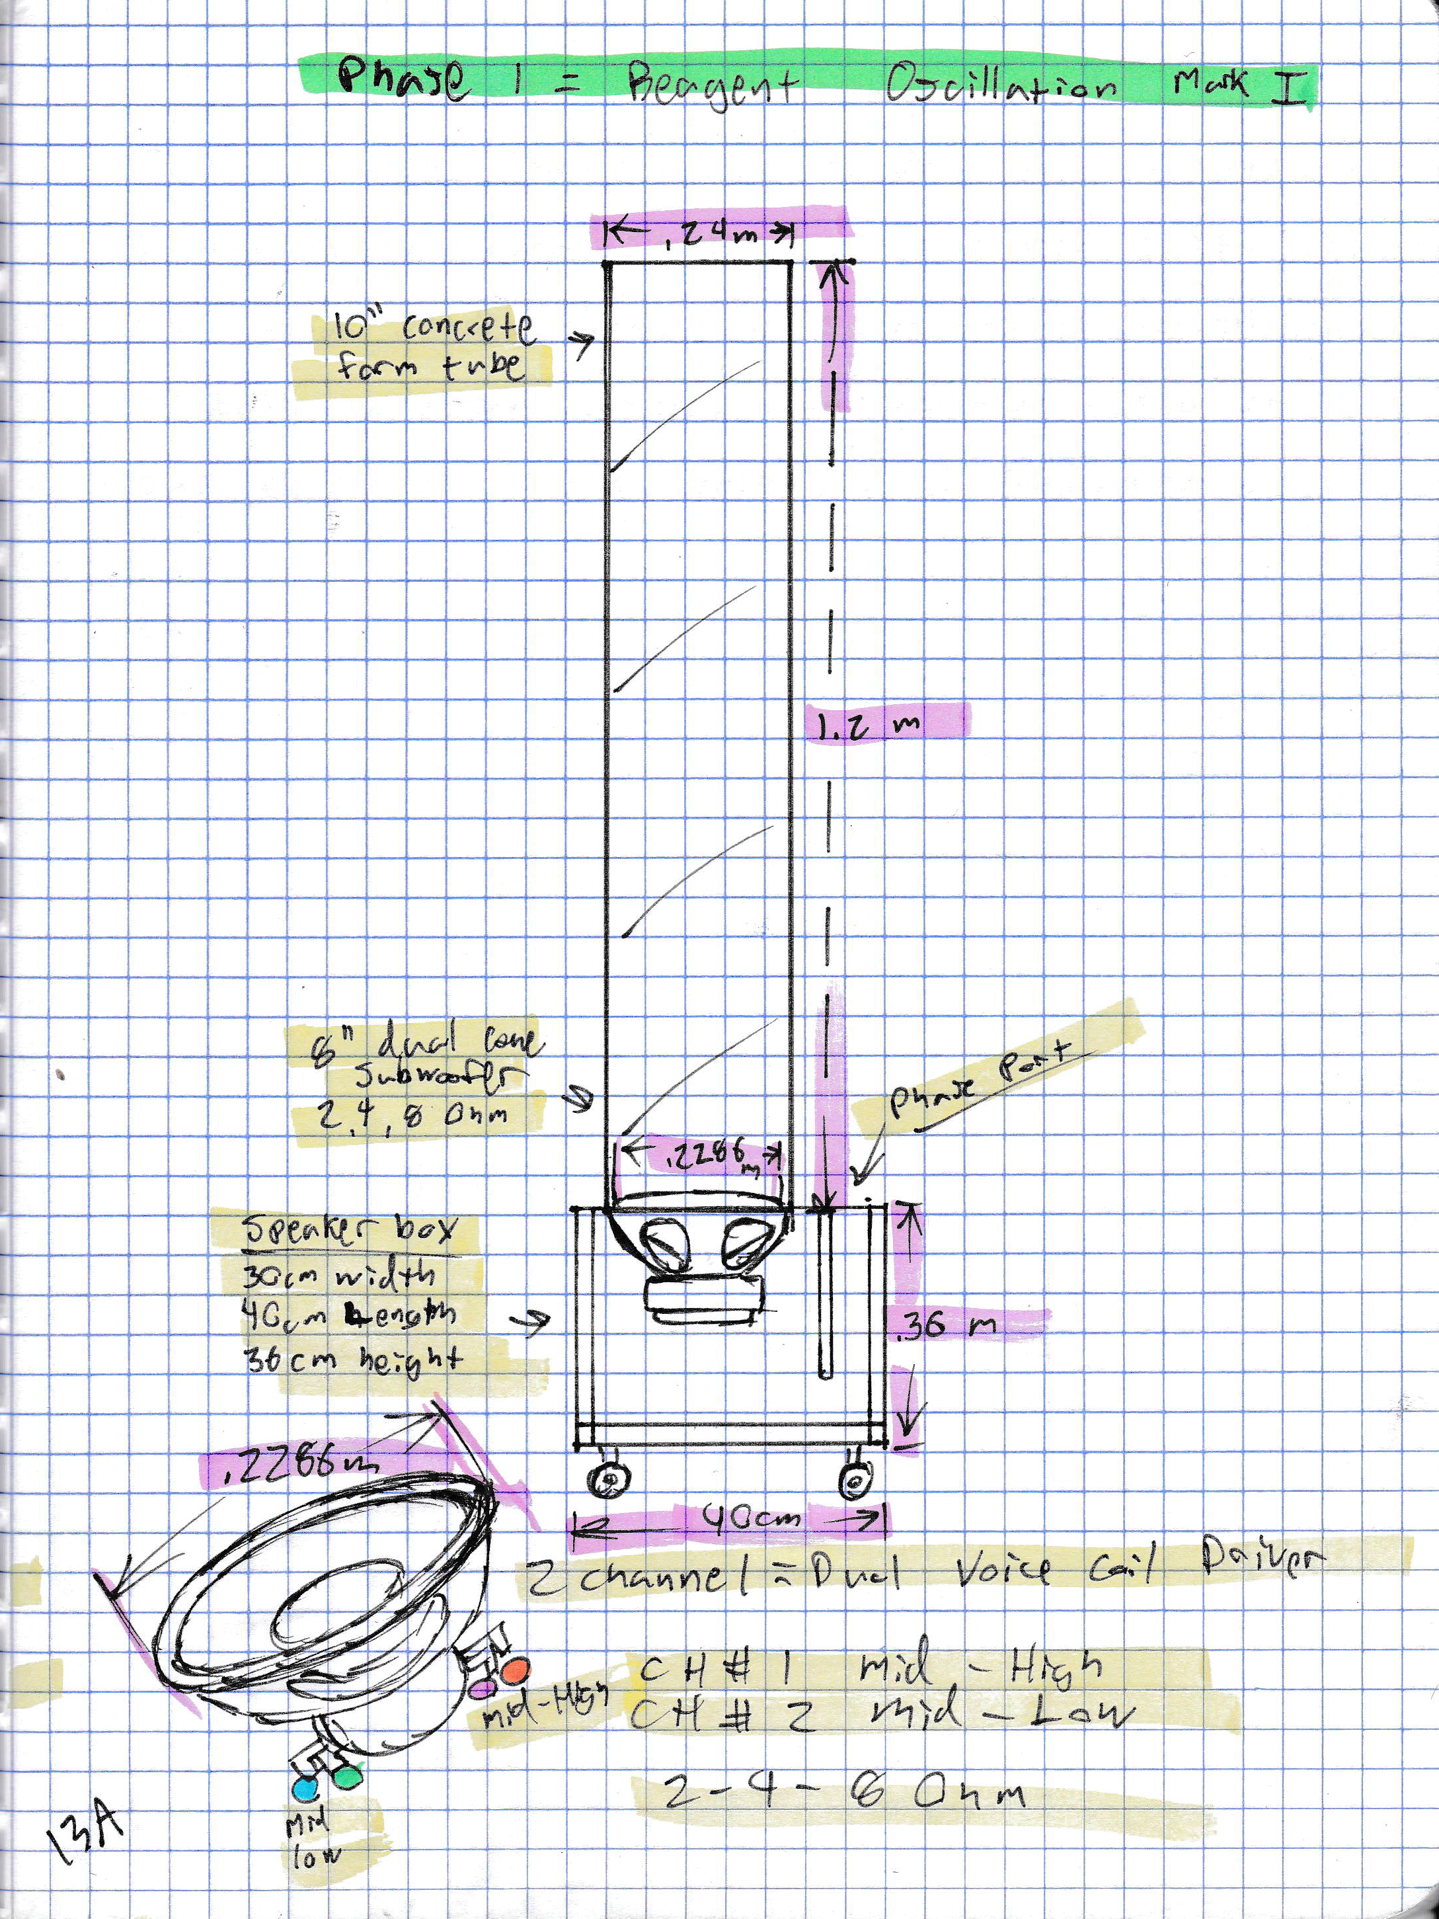The very first experiments involved a makeshift arrangement of cardboard form tube and speaker box. Experiments showed rotational patterns at 46-47 Hz, 76 Hz and around 118 Hz. Packaging tape was arranged to provide what was a temporary bond. Experimental amplitude was limited without an air tight joint from wave driver to column. The experiment had to be stopped after 2 hours of oscillation time intermittently spread out over 72 hours.

Film recorded this period shows dark locations within the formations of lycopodium as the substance is escaping the system. During these early experiments, an “add more so we can see what happens” method was used to attain observations and qualitative data which provided justification for the purchase of $200/ft acrylic tubing.

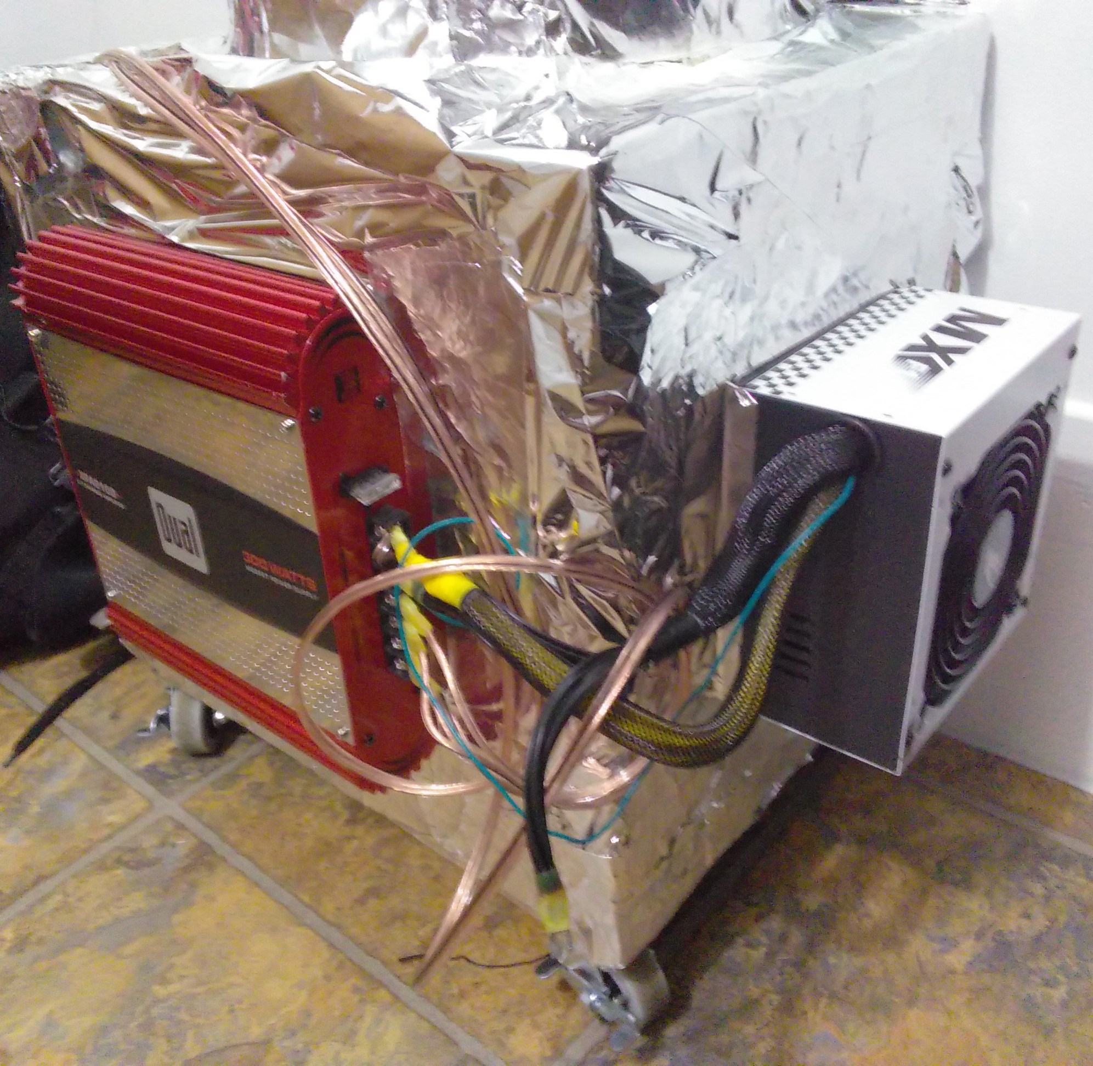During these early experiments, plastic material was used to separate the lycopodium powder from any electronic components which could create a hazard.

At the point at which a proof of concept was agreed upon by those who took part in observing video of the experiment, a purchase was made for extruded acrylic cylinder from eplastics.

When the cylinder arrived, an air tight bond of thermoplastic adhesive was used to create a seal between the dual coil wave driver and acrylic column. Upon drying overnight, the column was installed back into the main housing compartment. The protective plastic material was removed and testing began in an air tight environment.

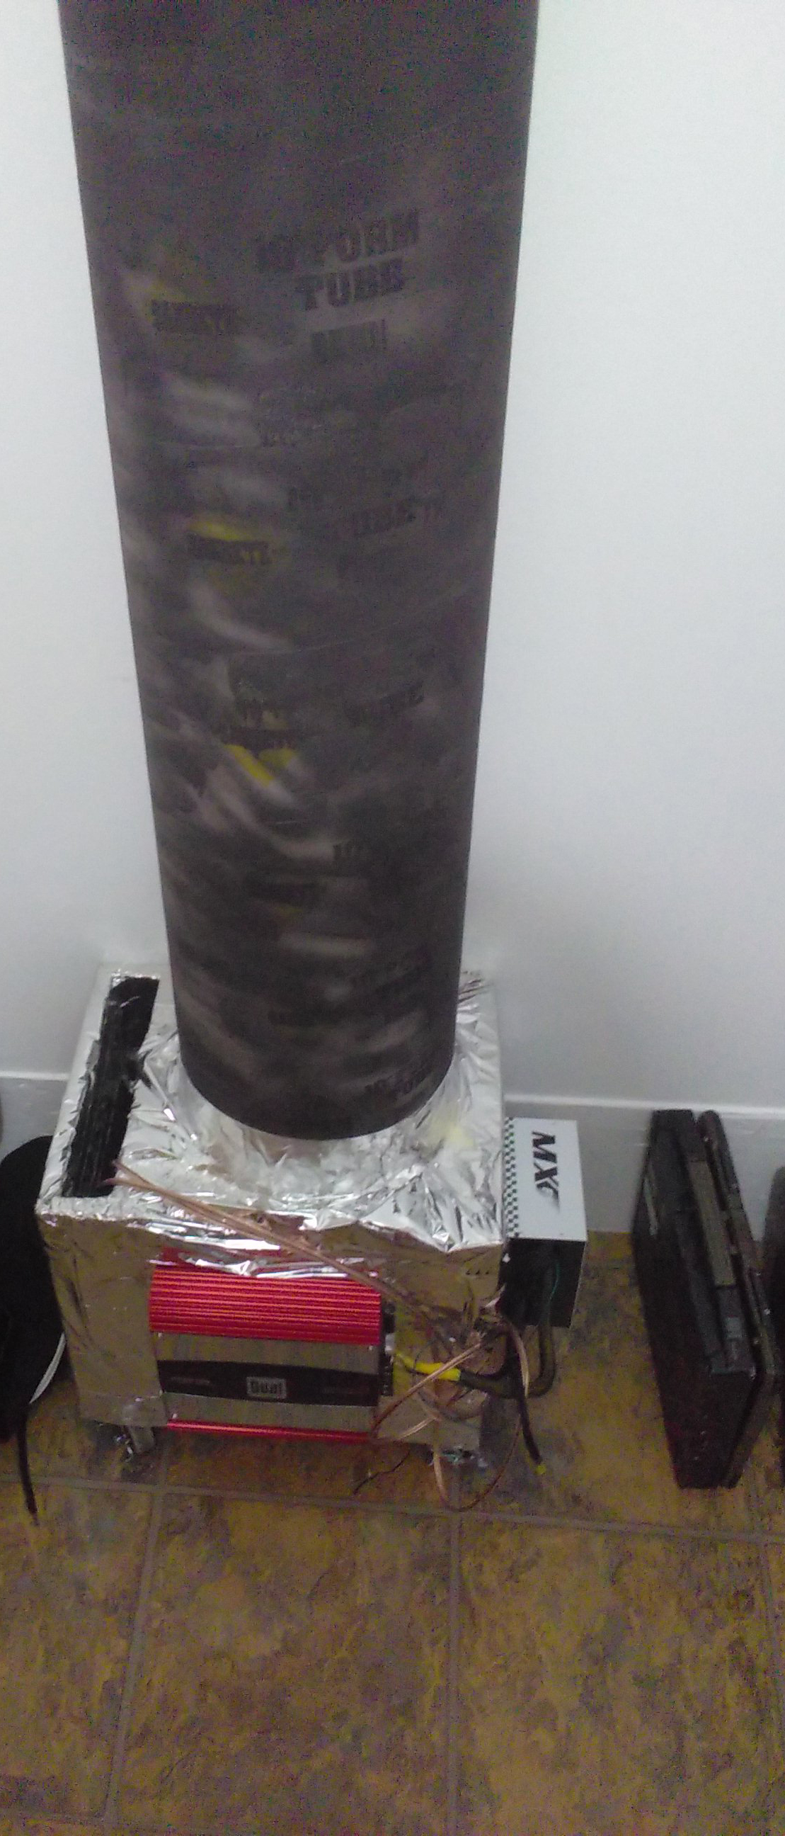During these experiments, amplitude was not limited by the physical environment except for clipping when playing low frequencies at very high volumes due to a power restricted wave driver. This allowed for nearly 6 hours of research before the power required by the dual coil wave driver became too much for the low budget 350-Watt power supply and 300-Watt amp. Again, qualitative observations were used to provide budget justification for a 1600-Watt amp to be purchased from Amazon to replace the failing 300-Watt amp.

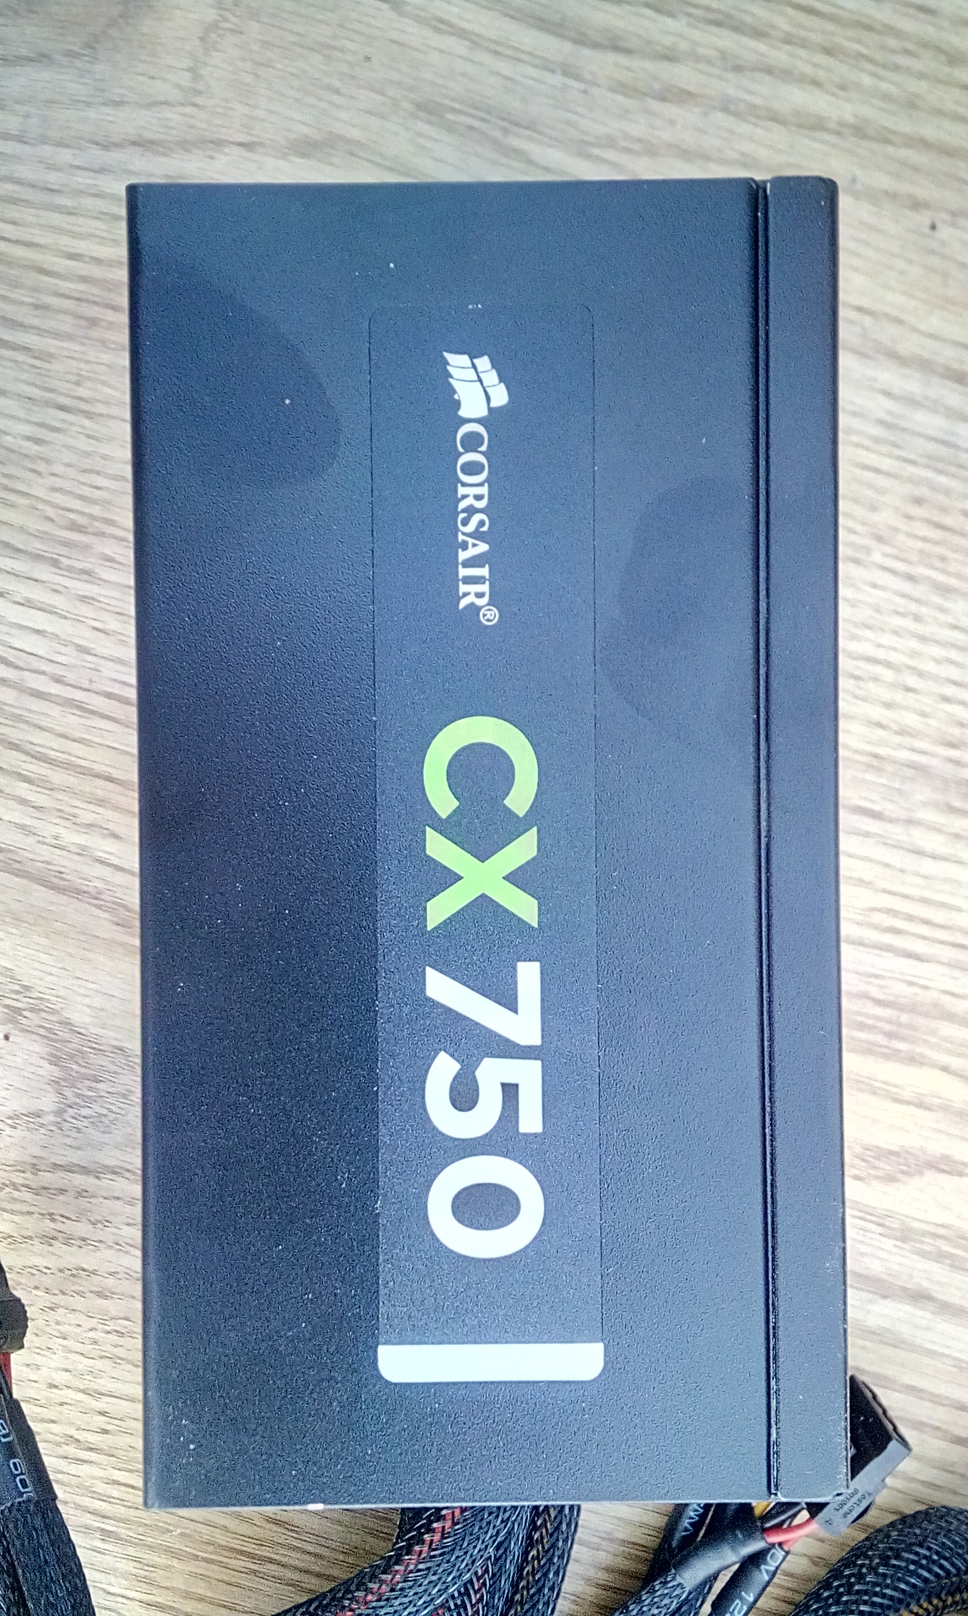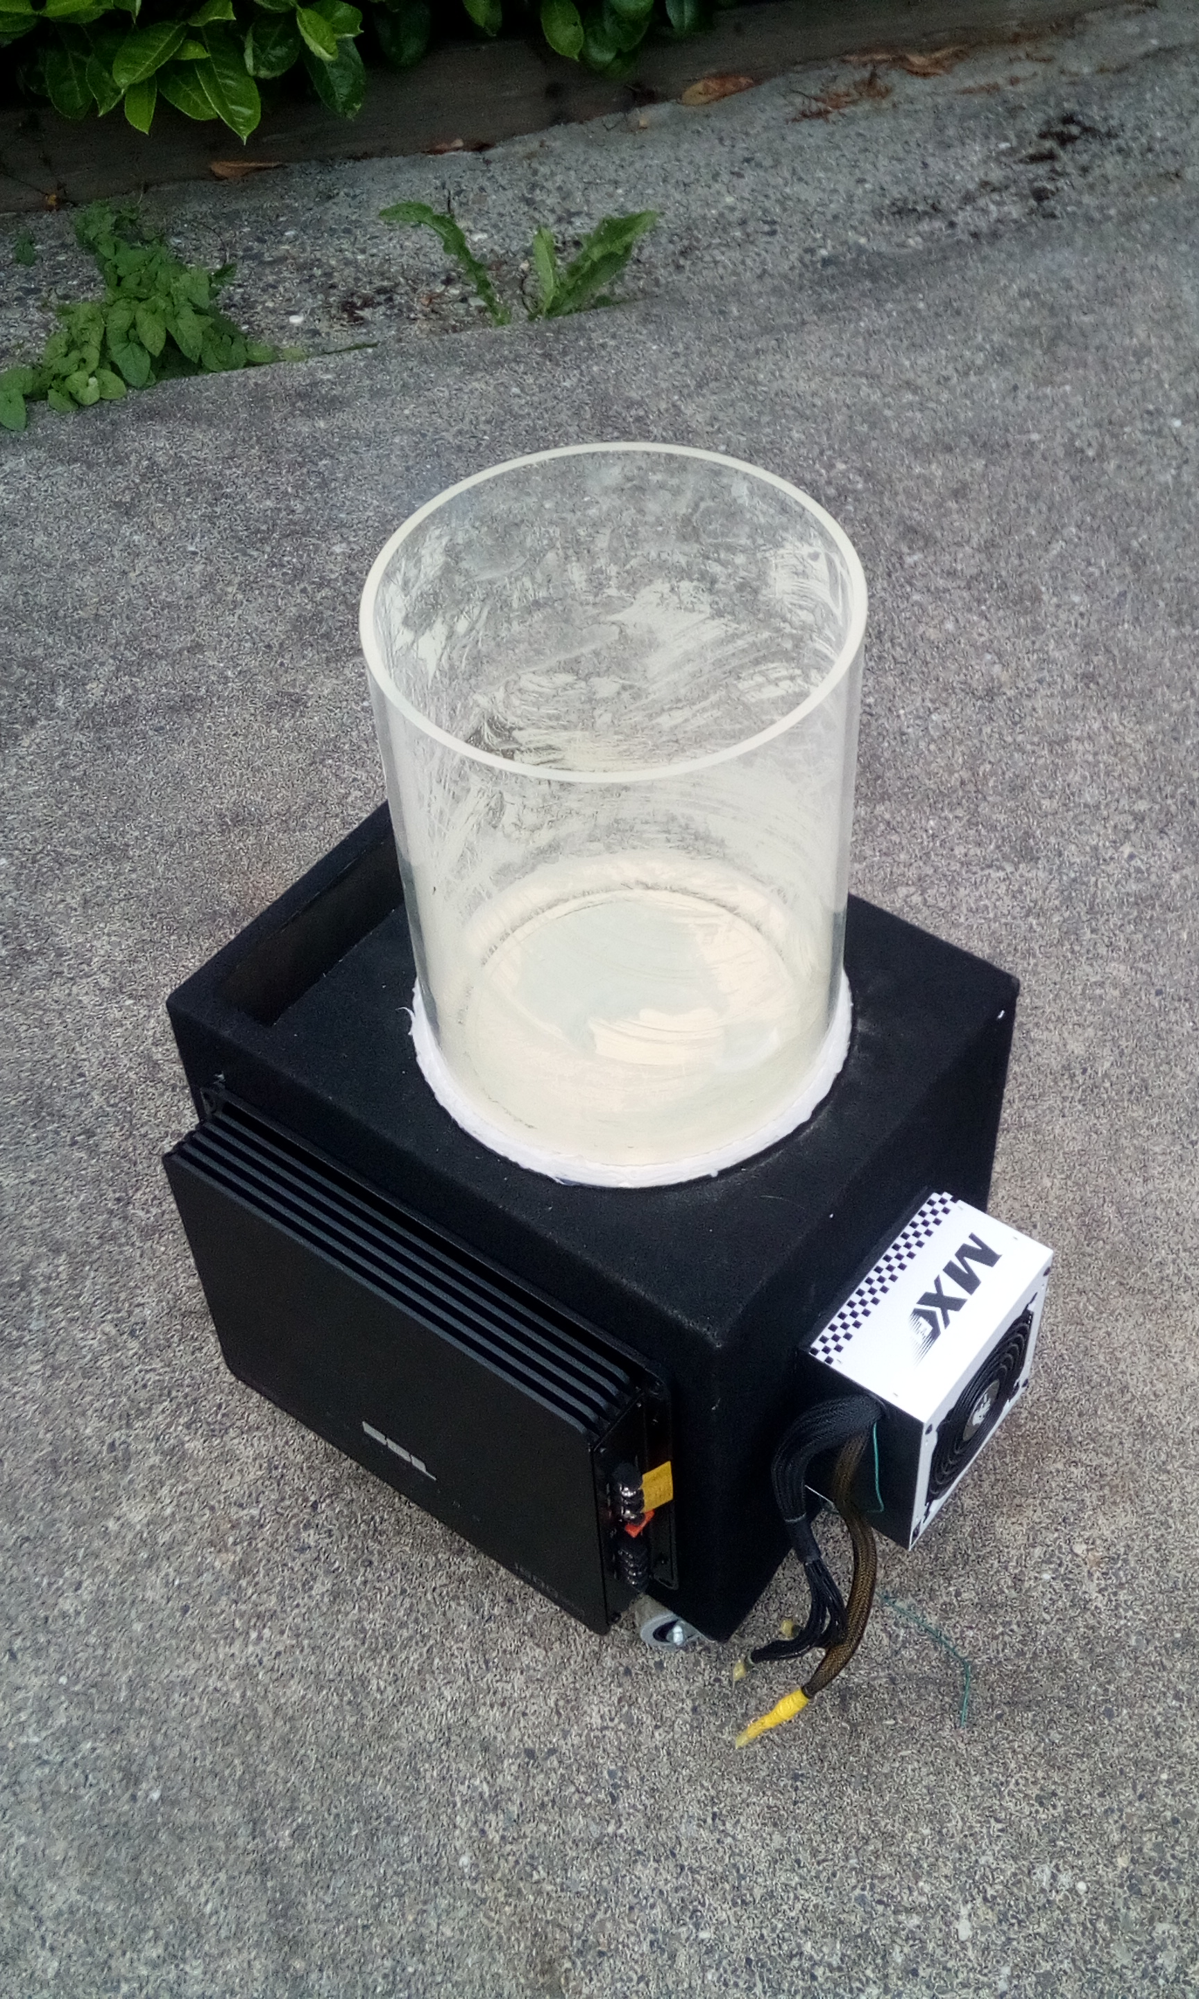A 750-Watt power supply is being converted to a lab power supply for this experiment in order to provide half of the 1600-Watt amp’s maximum amplitude. This is almost twice that of what was capable with the original configuration.

1. **Conclusion**

Methods for creating a functioning electroacoustic propulsion research lab from “Plasma Vortex Theory Vol.1” were improved through UGR 294 and independent study. Independent funds were used to start a process of prototyping suitable acoustic chambers, electroacoustic hardware, cathode / anode combinations, and power configurations.

Initial budget complications involved the costs to acquire core hardware components such as a wave driver and spherical column which were required to perform harmonic oscillations on test reagents. Secondly, finding an affordable method for generating an powering acoustical signals suitable for engineering research. In either case, the goal became to attain proof of concept with the lowest possible financial investment. A $20 9” dual coil wave driver was located at value village and acrylic listed at $200/ft was substituted with $7 form tube from Home Depot. A function generator and laboratory power supply were replaced with a 2013 MacBook Pro 17”, a $29.95 2-channel 300 Watt car audio amplifier and a $25 350 Watt computer power supply. Little fabrication was required aside from mounting equipment to a central housing and modifying the computer power supply to provide 12 VDC required for the audio amplifier. Details for the Lepa MX-1 power supply modification are available on GitHub.

Winter 2018 yielded new designs, experimental methods and plans to design and construct an experimental electroacoustic propulsion thruster were started. A modular lab design was chosen to observe the effects of sound waves in simple thruster designs of various configurations. Much of the early experimentation was a trial and error process of engineering and design, doing short experiments while making adjustments to the budget restricted lab environment.

In spring of 2018 the electroacoustic propulsion project was accepted as a privately funded independent study at North Seattle College by dean of sciences Alissa Agnello. The school has agreed to credit the independent research with the assistance of Ann Murkowski of the UGR program. In this independent study the institution is responsible for scientific review, while the project is given a S / NS grade based on scientific progress of agreed material which the researcher will produce.

This research project and all contents, theories and data are published as open source under the MIT License as to encourage peer review and open research. The goal of the wave assisted propulsion system project is to provide future mission planners of all nations with a novel method for converting electricity into flight hours. Throughout the research and development process, peer review, critiques, concerns and ideas are welcomed from students, engineers and scientists through GitHub, Researchgate and data repositories at Harvard Dataverse, Open Science Foundation and Figshare.

Upload and Organization of data is a work in progress. Content includes engineering designs, data, proposals, presentations, journals and video documentation of an undergraduate student engineering a breakthrough open-source research lab in public domain

1. **Data Repositories**

**Independent Study Repositories**

Open Science Foundation: [osf.io/nyfbd](https://osf.io/nyfbd/)

GitHub: <https://github.com/CoryAndrewHofstad/Electroacoustic-Propulsion>

ResearchGate: <https://www.researchgate.net/profile/Cory_Andrew_Hofstad>

Harvard Dataverse: <https://dataverse.harvard.edu/dataverse/CoryAndrewHofstad>

FigShare <https://figshare.com/articles/Electroacoustic-Propulsion/6483689>

YouTube: <https://www.youtube.com/channel/UCxmwDUhxdz6-7XQDHh60G8Q>

**Undergraduate Research Repositories**

<https://github.com/UGR294>

Future located on fork: <https://github.com/CoryAndrewHofstad/Plasma-Vortex-Theory>

**References**